TOEIC SPEAKING: DESCRIBE THE PICTURE
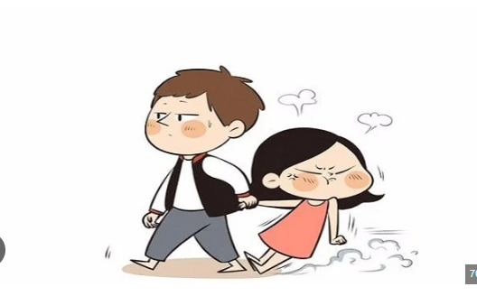

Level A1: Simple and Funny
Look at this funny picture! There is a boy and a girl. The boy is walking, but he looks very calm and a little bit annoyed. The girl is behind him. She is not walking; she is sliding on the floor! She looks very angry. Maybe she is mad because she wants ice cream, or maybe she is just grumpy today. The boy is pulling her like a heavy bag. It is a very silly situation!
Level A1: Another Simple and Funny Version
This is a very funny picture! There is a boy and a girl. The boy is walking fast and looking forward, but he is pulling the girl. The girl is very angry! She is sliding on the ground and her face is very red. It looks like the boy wants to go home, but the girl wants to stay. Maybe she wants to buy a toy! It is a very silly and cute scene.

CÁC CỤM TỪ MIÊU TẢ HÀNH ĐỘNG VÀ CẢM XÚC
- "Sliding on the floor/ground": Trượt trên sàn/mặt đất (rất sinh động để tả hành động của cô gái).
- "Look very calm": Trông rất bình tĩnh.
- "A little bit annoyed": Hơi khó chịu một chút.
- "Look very angry": Trông rất giận dữ.
- "Walking fast": Đi bộ nhanh.
- "Pulling someone like a...": Kéo ai đó như thể là... (cách so sánh rất hài hước).
CÁC CỤM TỪ DÙNG ĐỂ DẪN DẮT CÂU CHUYỆN
- "Maybe she is...": Có lẽ cô ấy đang... (cách suy đoán tình huống).
- "It looks like...": Trông có vẻ như là... (dùng để diễn đạt phỏng đoán dựa trên hình ảnh).
- "It is a very silly situation/scene": Đó là một tình huống/khung cảnh rất ngớ ngẩn (hài hước).

